JAMIA MILLIA ISLAMIA, NEW DELHI

COMPILER DESIGN LAB

NAME: FAIZAN CHOUDHARY

ROLL NO: 20BCS021

SUBJECT CODE: CEN 692

SEMESTER: 6th

COURSE: B.TECH.(COMPUTER ENGG.)

DEPT: DEPT OF COMPUTER ENGG.

SUBMITTED TO:

DR. SARFRAZ MASOOD

|  |  |  |  |  |
| --- | --- | --- | --- | --- |
| S. NO. | DATE | PROGRAM | PAGE | SIGN |
| 1 | 18/01/2023 | DFA | 3 |  |
| 2 | 01/02/2023 | Mealy Machine | 6 |  |
| 3 |  |  | 13 |  |
| 4 |  |  | 15 |  |
| 5 |  |  | 17 |  |
| 6 |  |  | 19 |  |
| 7 |  |  | 21 |  |
| 8 |  |  | 23 |  |
| 9 |  |  | 25 |  |
| 10 |  |  | 27 |  |

FAIZAN CHOUDHARY

20BCS021

18th January, 2023

CODE:

#include <iostream>

#include <stdlib.h>

#include <vector>

#include <fstream>

#include <sstream>

#include <string>

using namespace std;

vector< vector<int> > dfa;

int initial_state;

vector<int> final_states;

int find (vector<int> &arr, int key) {

    for (int i=0; i<arr.size(); i++)

        if (arr[i] == key)

           return i;

    return -1;

}

string check(vector< vector<int> > &dfa, string input) {

    int curr_state = initial_state;

    int i=0;

    cout<<"\nTransitions: ";

    while (i < input.size() && curr_state != -1) {

        curr_state = dfa[curr_state][input[i]-'0'];

        if (curr_state != -1)

            cout<<"q"<<curr_state<<" -> ";

        else

            cout<<"Dead state ";

        i++;

    }

    cout<<endl<<endl;

    if (curr_state == -1)

       return "NOT ACCEPTED: DEAD STATE";

    else if (find(final_states, curr_state) == -1)

       return "NOT ACCEPTED: NON FINAL STATE";

    return "ACCEPTED";

}

int main() {

    ifstream fin;

    fin.open("dfa.txt");

    int curr_line = 0;

    string line;

    cout<<"\n20BCS021\nFAIZAN CHOUDHARY\n\n";

    cout<<"Given DFA: "<<endl;

    // read until EOF

    while (getline(fin, line)) {

        cout<<line<<endl;

    }

    // clearing eof flags and seeking to start of file

    fin.clear();

    fin.seekg(0);

    while (fin) {

        getline(fin, line);

        vector<int> temp;

        if (curr_line == 0)

           initial_state = line[0] - '0';

        else if (curr_line == 1) {

            for (int i=0; i<line.size(); i++) {

                if (line[i] != ',') {

                    final_states.push_back(line[i] - '0');

                }

            }

        }

        else {

            for (int i=0; i<line.size(); i++) {

                if (line[i] != ' ') {

                    if (line[i] == '-') {

                        i++;

                        temp.push_back(-(line[i] - '0'));

                    }

                    else

                        temp.push_back(line[i]-'0');

                }

            }

            dfa.push_back(temp);

        }

        curr_line++;

    }

    string input;

    cout<<"\nEnter input consisting of 0's and 1's: ";

    getline(cin, input);

    // if (input.size() == 0)

    string ans = check(dfa, input);

    cout<<ans<<endl;

    fin.close();

    return 0;

}

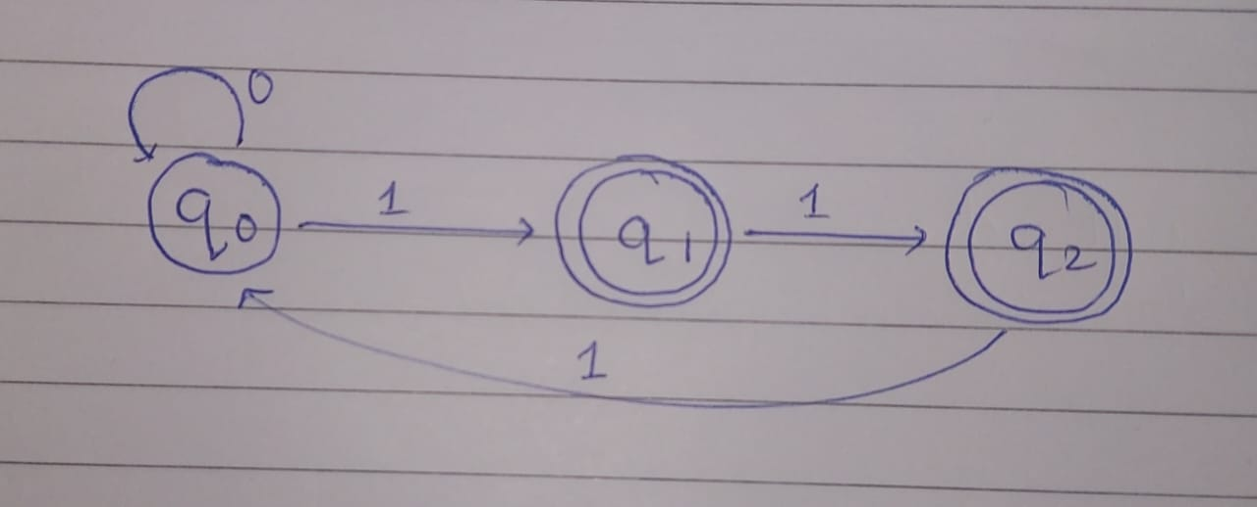

DFA used

OUTPUT:

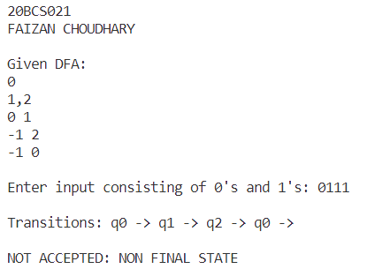

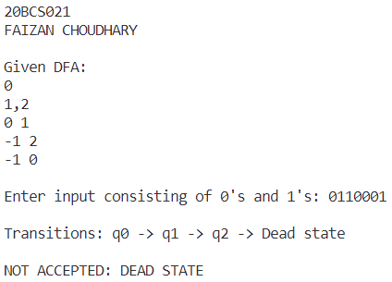

FAIZAN CHOUDHARY

20BCS021

1st February, 2023

CODE:

#include <iostream>

#include <stdlib.h>

#include <vector>

#include <fstream>

#include <sstream>

#include <string>

using namespace std;

vector< vector<pair<int, char> > > mealy;

int initial_state;

string check(string input) {

    string out;

    pair<int, char> t = {initial_state, ' '};

    int i=0;

    cout<<"\nTransitions: ";

    while (i < input.size() && t.first != -1) {

        t = mealy[t.first][input[i]-'0'];

        if (t.first != -1)

            cout<<"q"<<t.first<<" -> ";

        if (t.first == -1)

            break;

        else

            out += t.second;

        i++;

    }

    cout<<endl;

    return out;

}

int main() {

    ifstream fin;

    fin.open("mealy.txt");

    int curr_line = 0;

    string line;

    cout<<"\n20BCS021\nFAIZAN CHOUDHARY\n\n";

    cout<<"Given Mealy: "<<endl;

    // read until EOF

    while (getline(fin, line)) {

        cout<<line<<endl;

    }

    // clearing eof flags and seeking to start of file

    fin.clear();

    fin.seekg(0);

    while (fin) {

        int state;

        char output;

        vector< pair<int, char> > temp;

        getline(fin, line);

        if (curr_line == 0)

           initial_state = line[0] - '0';

        // no final states in mealy

        else {

            for (int i=0; i<line.size(); ) {

                if (line[i] != ' ') {

                    if (line[i] == '-') {

                        i++;

                        state = (-(line[i] - '0'));

                        output = (' ');

                        temp.push_back({state, output});

                        i+=5;

                    }

                    else {

                        state = (line[i]-'0');

                        output = (line[i+2]);

                        temp.push_back({state, output});

                        i+=4;

                    }

                }

            }

            mealy.push_back(temp);

        }

        curr_line++;

    }

    string input;

    cout<<"\nEnter input consisting of 0's and 1's: ";

    getline(cin, input);

    string ans = check(input);

    cout<<"Output of Mealy machine: "<<ans<<endl;

    fin.close();

    return 0;

}

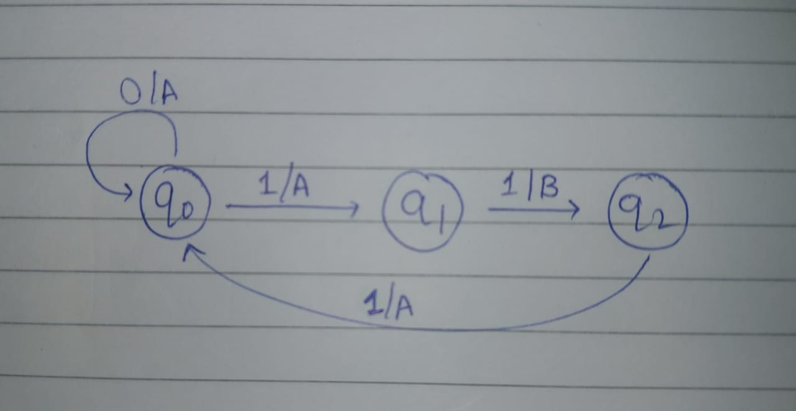

Mealy Machine used

OUTPUT:



